Project Development Phase

**Sprint-2**

Profile- To Know the User about Him/ Her Information and provide to Generate the Report for his Analysis

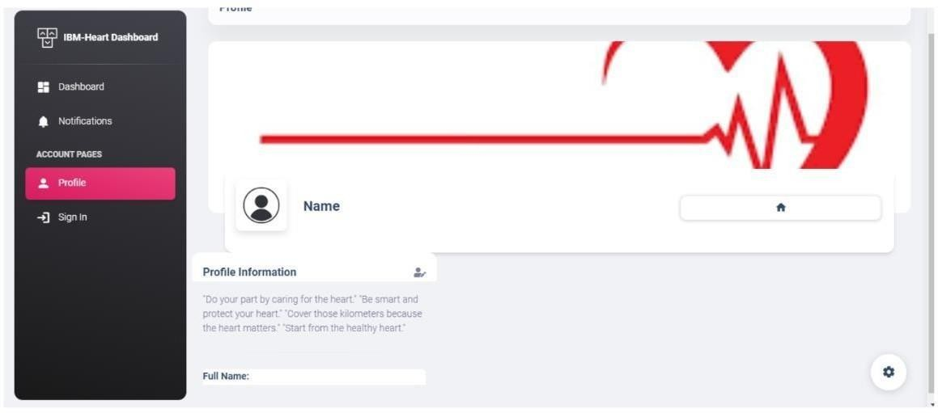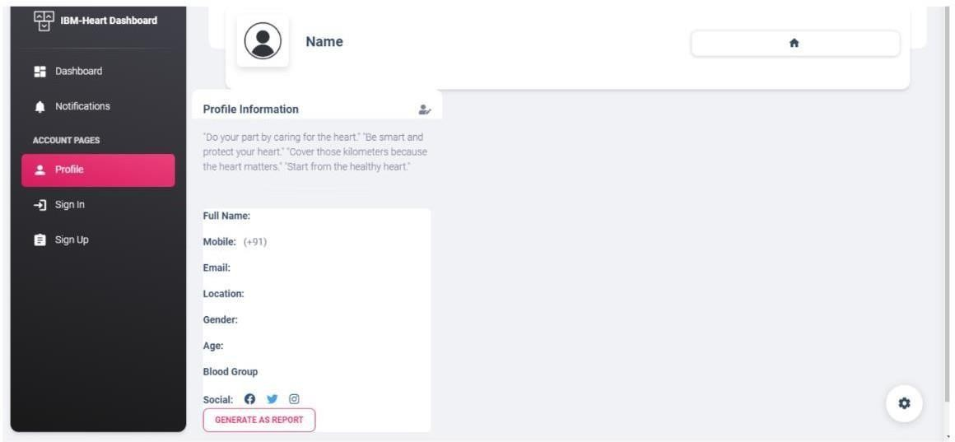

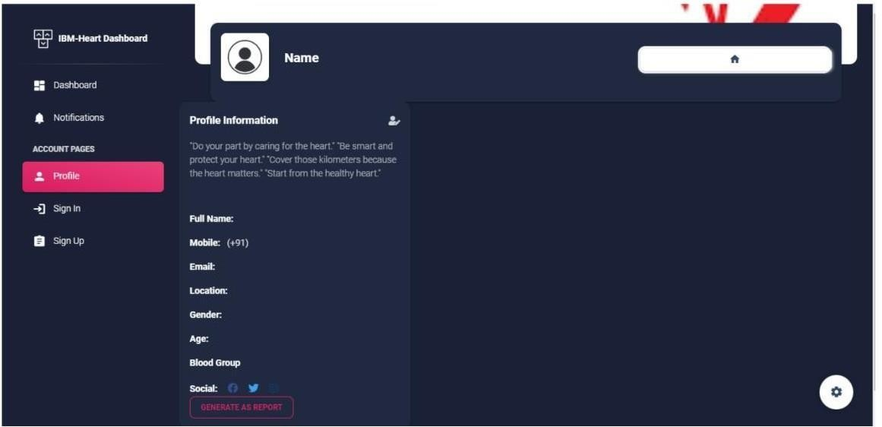

**Dataset collection** - The data required for analysis and prediction must be collected from various sources, Collecting Dataset from Different Site

